PUNTLAND STATE OF SOMALIA
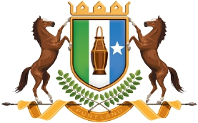

MINISTRY OF COMMERCE, INDUSTRIES & INVESTMENTS

Date: May 21, 2022
PUNTLAND INVESTMENT OPPORTUNITIES
Background
Puntland, officially Puntland State of Somalia is a region located in Northeastern Somalia with the town of Garowe in Nugaal province as the capital. in 1998 Puntland official become autonomous region in Somalia which helped it regain the stability during the civil wars. In the last few years, the situation has become much better and there were a few large investments which significantly improved the general state of the economy in the region. Bosaso is now one of the fastest developing cities in the entire Africa.
Dating back to approximately three decades ago, Puntland and Somalia at large were considered as a state which had a potential for rapid industrial and business growth. There were so many businesses flourishing such as agro-based industries, fish processors, dairy farming, salt production, steel rolling mills among others. In addition, there used to be massive growth of Small and Medium Enterprises (SMEs) and hence the standards of living, levels of income and employment rates were high compared to the present day. It should be remembered that the GDP for Somalia was high per annum characterized by large volumes of exports and imports and a large domestic market.
Puntland regions had very strong international trade relations with various countries especially in the Middle East such as Yemen, Saudi Arabia, Oman among others but these declined during and after the civil wars. Production for the local market was massive and there was massive growth of infant domestic industries which had helped in ensuring the execution of the then government’s import substitution strategy and saving the would-be expenditure on foreign imported commodities.
Somalia has the longest cost in Africa, and Puntland boasts over a third of that with 1,300 km. its beaches are largely untouched and perhaps the most beautiful coastline in the entire African continent. It represents pure nature and heaven like beauty. A swim on the beaches of Puntland is certainly unforgettable experience. The coastline of Puntland abundant with fish as well as other natural marine resources. As a matter of fact, of the entire coastline in Somalia, Puntland has the reaches habitats and that’s what makes it so attractive and desirable.
An estimated 200–300 tons a year of lobster tails are exported annually. Lobster catches are processed into tails at the beach, mostly by fishers themselves.
The commercial sector has been on the gradual positive rise and Puntland’s economy grew at over 5% in 2019 compared with just over 1% in 2018 and over 3% for all of Somalia (the Somali economy contracted by 1.5% in 2020 because of the COVID-19 pandemic). The value of exports was unchanged in real terms in 2019, with most (86%) from livestock and related products and the rest from frankincense and fish. Anecdotal evidence suggests Bossaso forms a large part of Puntland’s economy.
Why Invest Puntland
Puntland State is located in the heart of Somalia. It has a good advantage point for linkages in whole Somalia, Somali Region of Ethiopia and the Gulf Arab Countries with the following characteristics:
- Political stability to secure long term investment
- Strong and functioning government institutions that upholds the rule of law and good governance
- Rich in natural resources and various mineral deposits
- Key strategic location and logistics hub (Bab el-Mandeb and routes through the Red Sea and Suez Canal)
- Puntland’s business capital has two international port ( Bosaso port and Gara,ad Port), with easy access to the external world.
- Availability of good road network systems;
- Air network at two international airports in Bossaso and Garowe with capacities to accommodate large aircraft for Cargos. A number of airstrips exist in other districts;
- Availability of fibre optic cable system for high-speed internet connectivity.
- Low Labour Costs and 70% young population below the age of 30
- Wide Market Access
- Favourable Investment Policies/laws
- Favourable Investment Climate
- Vibrant and growing private sector
- There is also a Chamber of Commerce in place within the State.

Key sectors to invest
- Livestock sector
Livestock production has been the backbone of Puntland state economy for many centuries.it is the most important source of food and income for the predominantly rural population as well the country biggest export commodity. Livestock account 60% of employment and 40% of the GDP and as well 80% of all export earnings.
The livestock kept in Puntland are indigenous breeds of goats, sheep, camel and cattle breads that are more adaptable to arid environment and more resistance to diseases, drought and capable of surviving on poor nutrition that have become major challenges to livestock production.
Due to the low production of livestock mainly due to the lack of processing industries in animal products. The foreign investors can have the following opportunities in livestock subsector:
- Extensive ranging and Fodder production/processing factories
- Tanning hides and skins industries
- Feedlot finishing/fatting farms
- Livestock production materials and processing equipment’s
- Investment of Slaughter houses with proper international standard and design for export of fresh chilled Meat
- Dairy farm processing industry
- Poultry farms for egg and chicken meat supply
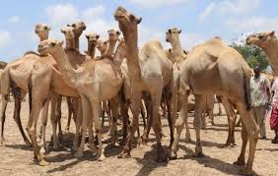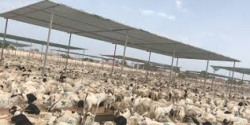
Fig 1: Types of livestock sectors in Puntland ready for export
- Fishery sector
The Somali coastline is 3,300 km long. From this, the proportion attributable to the state of Puntland is approximately 1,300Km2 extending from Gara,ad on the Indian Ocean side to laaso surad on the Gulf of Aden, the waters of which incidentally constitute the richest fish habitats in the region.
The fish population in Puntland Coastal waters varies in diversity and density. It is known that the prevalent species are large pelagic varieties such as yellow fin tuna, long tail tuna, bonito, skipjack, and Spanish mackerel, while the main commercial demersal fish are grouper, snappers, grout and Sea beam. Large populations of Shark and Ray are also registered. Commercial populations of inshore spiny lobster, genus Panuliras, and Offshore types of puerulus sewell,and puerulus carinatus are found at depths 150-400 meters. The abundance of marine resources, characteristic of Puntland coastal zones by virtue of its geographic location makes it worth investing. The foreign investors can have the following opportunities in fish subsector
- Investment of fish processing plants and canning factories.
- Provision of sufficient fishing gear and accessories.
- fish handling and processing facilities and techniques;
- Fish Cold storage/refrigeration facilities/plants for fish export
- Quality control system
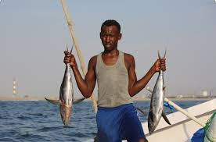
Fig 2. A young boy hanging fresh fish exported in Puntland
- Agriculture sector (cash crops)
Puntland agriculture sector has made headway since 1998 when Puntland State administration for formed, farmers for progress made in agricultural productivity in Puntland. Major progress in agriculture in Puntland has been made since 1992. Displaced people have introduced growing of vegetable and fruits. Vegetable and fruits such as papaya, salad, carrots, tomato , lemon, and cucumber consumed in Puntland grow in local farms. There are crops we have in common the rest of Somalia, and crops such as coffee and garlic that grow in Puntland. The foreign investors can have the following opportunities in agriculture (crops) subsector
- Invest Crops grown under irrigated farming include Vegetable and fruits such as papaya, salad, tomatoes, onions, lettuce, spinach, capsicums, carrots, okra, cowpeas, watermelon, lemon, and cucumber.
- Invest Sorghum, millet, maize, sim sim (sesame) and several types of fruit trees.
- Invest Crops such as coffee and garlic that grow in Puntland,
- Dates farming
- Yi’ib (yicib)
- Provision of modern irrigation and agricultural equipment’s
- Provision of modern greenhouse and farm technology.
- Frankincense investment: Two types of commercial frankincense are collected. MAYDI (Boswellia Frereania) From YAGCAR trees and BEEYO (Bowellia Sacra) from moxor trees, MAYDI frankincense is exclusive for Somalia, while BEEYO varying in variety is produced in Ethiopia (Somalia region), Eritrea, Oman and India. Other varieties exploited commercially include the opopanox, which is a source of gum: myrrh, and Arabian Gum. Moreover, the woodland varieties of frankincense - commiphora, grow in the inland areas of Puntland
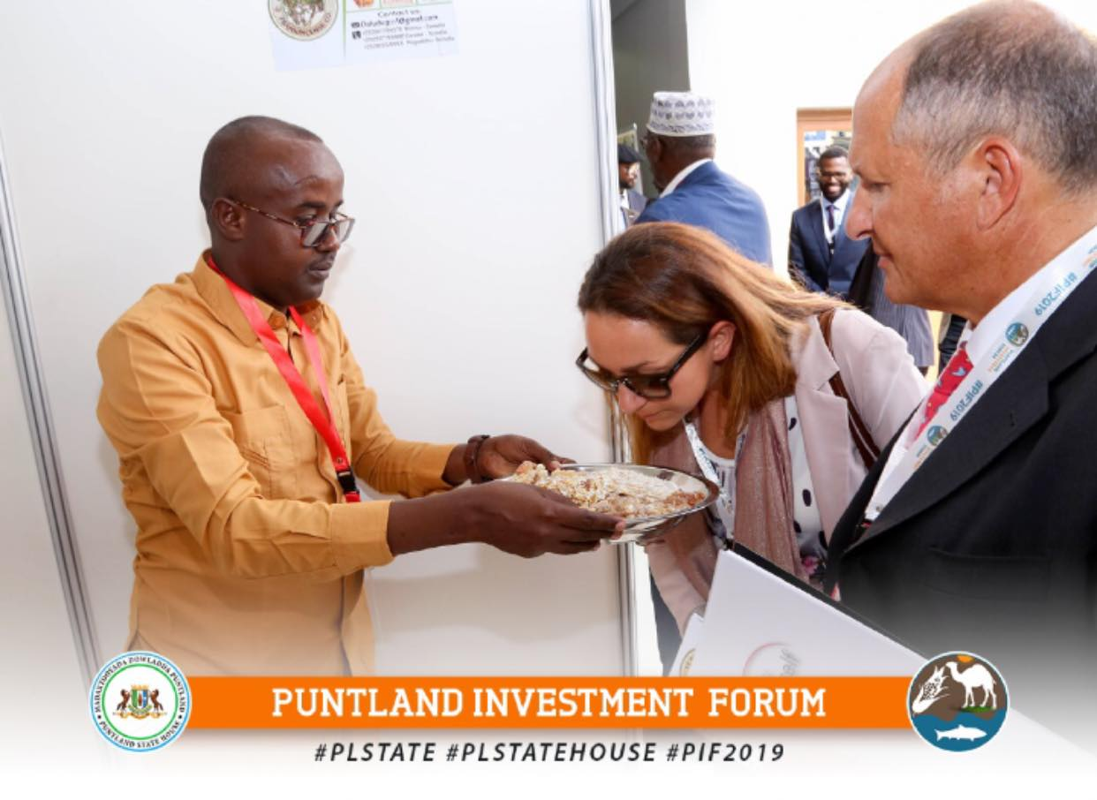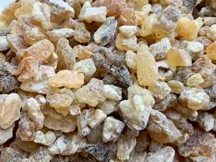
Photo 4. Puntland entrepreneurs showing foreign investors in Franckcinse that are avaialable in Puntland
- Construction and real estate sector
A new housing boom in Puntland, riding on increased demand, a sizable population returning from the diaspora in the wake of stability has seen the emergence of elegance, class and tastes on the sector that has now seen an appreciation in the real estate sector.
A number of successful residential projects has been undertaken in Puntland. Most notably are Green city in Bosaso , Amal and Emad real states in Garowe. There is huge demand in Puntland in quality construction companies for roads and key public infrastructures and housings. The foreign investors can have the following opportunities in construction sector.
- Investment in the construction of key public infrastructures such as roads, ports, air ports, free economic zones, industrial parks, dums, and shallow wells etc,
- Provision of affordable construction materials
- Real state and housing constructions
- Investments in Cement Plants
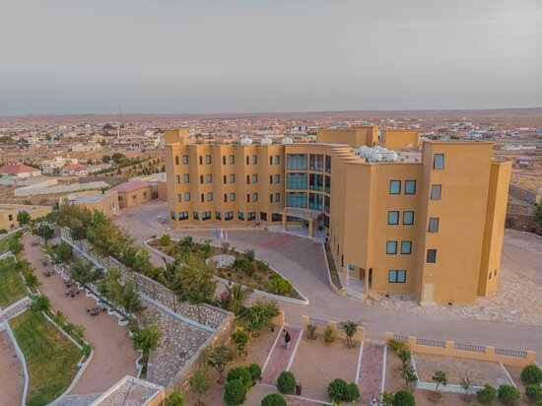
Photo 5: Martisoor Hotel one of the five-star hotels in Garowe- constructed by real estate developers

- Manufacturing sector
Manufacturing sector is one of the crucial sectors, the Puntland State of Somalia is promoting in order to realize significant export volumes and create more jobs. Locally manufactured goods should be competitive and offer additional value in order to increase local consumption.
Puntland is currently an import dependent and most of the imports are food related items which is local produced but lack processing and manufacturing elements. Substantial investments are needed in order to reduce this import/export imbalance while potentially increasing export once local demand is met. Manufacturing will eventually transition Puntland from an agriculture-based economy to a more resilient and stable industry-based economy with potential diversification to the service-based economy.
Currently, Puntland has got limited manufacturing activities such as Ilo-tango Company processes a variety of beverage items as well as plastic bags and water beverages companies. however various opportunities exist and the foreign investors can have the following opportunities in Manufacturing subsector:
- Leather processing Factories/industries
- Investments in Hides and skins processing plants
- Water purification industries
- Milk processing industries
- Plastic Recycling industries
- Meat and fish tanning industries
- cement factory
- investments in special Economic Zones
- Investments in Warehousing facilities
- Industrial Engineering and Maintenance
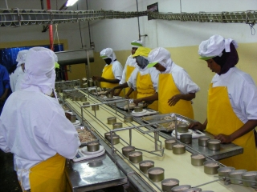
Photo 6: Inside of Fish processing factory in habo districts of Puntland
- Bank & Finance
The number of people with bank accounts has double and this is associated with rapid increase in banking licences, with 13 banks now licensed compared with 5 licences in 2018. Several banks have branches in Puntland, including Amal Bank, IBS, Salaam Bank, CAC International, Don Kamal Bank, Maamuus International Bank, and Tawakal Bank.

Some of these private banks are a mixture of money transfer businesses and banking at the same time. Some examples of the mixture services of hawala and banking are Dahabshil Bank International (DBI), Salaam Bank and Amal Bank. Dahabshiil is one of the old money transfer companies in Somalia, and Salaam Bank is a sister organization of Golis telecom. The premier and IBS bank currently provide Master and Visa Cards that consumers can use worldwide transactions. The majority of these financial institutions are headquartered in Garowe capital city with branches in the regions.
There is huge investment opportunities in banking and finance as Puntland private sector is thriving. Below are the investment opportunities in banking and finance:
- Independent ATM operators
- Investments in rural credit and microfinance services for agriculture
- Investments in pension funds management
- Investments in insurance services
- Savings and Credit Cooperatives
- Online payments processing and settlements etc.
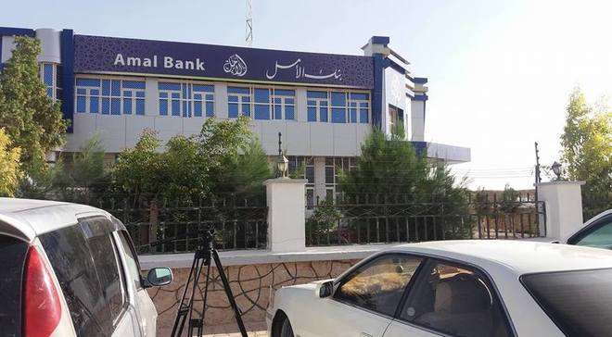
Photo 7: one of the local banks in Garowe that provides banking and remittance services
- Mining and Energy Extractive Industries
Puntland economy is growing and needs affordable energy to continue developing. The National energy deficit in the country is considerable proving an opportunity for potential investment. As a priority enabling sector, investments to offer competitive energy prices and alternatives to current energy sources (generators, charcoal) will prove profitable for both investors and government.
According to AfDB’s assessment, the energy mix is dominated by charcoal and firewood; meeting nearly 80 to 90% of the energy needs of the whole country and undermining manufacturing and forest sustainability. Renewable energy sources are a viable and immediate way to increase affordable energy for Somalis.
Investments in renewable energy are multiplying in Africa as the costs of renewable technologies decrease. Puntland State of Somalia has one of the highest potentials for onshore wind power in Africa and one of the highest rates of daily total solar radiation in the world. The cost of renewable energy options is decreasing and are now often less expensive than diesel options.
Gemstone and gold mining activities are being carried out in the mountain areas of Puntland by several local businesses that tend to use simple manual equipment. While these businesses frequently obtain and produce marketable products of various precious stones and gold sands, there is ample opportunity for further investment and expansion of capacity.
Puntland also exhibits many positive indicators for the presence of hydrocarbons Investment opportunities in Mining and Energy Sector
- Exploration of hydrocarbons and petroleum
- Solar energy generation
- Transformer and electric cabling manufacturing
- Supply and installations services
- Wind power generation
- Recycling Power generation plant
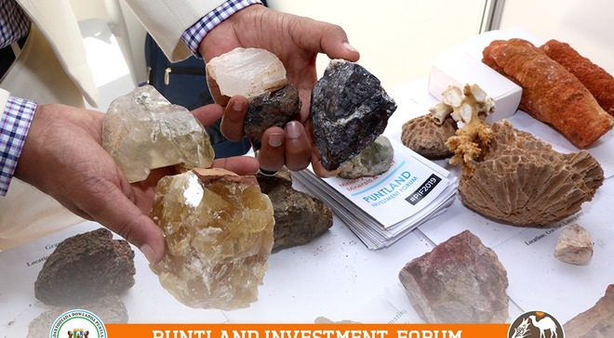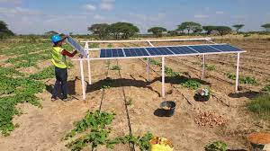
Photo 8: types of minerals found in Puntland and renewable energy investment in Agriculture

- Salt
Sodium chloride, also known as salt, common salt, or table salt, is an important product in all countries around the world, including Puntland State of Somalia. Salt is added to food, either by the food producer or by the consumer, as a flavor enhancer, preservative, binder, fermentation-control additive, texture-control agent and color developer. In tanning and leather treatment, salt is added to animal hides to inhibit microbial activity on the underside of the hides and to attract moisture back into the hides. It is also used in food processing including packing, canning, baking, and dairy and grain mill products. Salt is used in industrial applications and processing including oil and gas exploration;
In textile dyeing and in processing heavy metals like aluminum, beryllium, copper, steel and vanadium. In addition, salt is used in rubber manufacturing and in paper and pulp industry, and to increase the curing of concrete in cemented casings and to provide firmness to highway bridge foundations. Among the other uses of salt include pharmacological products and veterinary medicines etc. and to melt snow in many cold countries during winter.
In Puntland the salt rich areas are Hafun and Hurdiyo strategic hubs that form the tip of Horn of Africa. During the former central government of Somalia Italian cooperative at the time produced around 200,000 metric tonnes of Salt and exports mainly went to far east Asia. Neighboring Ethiopia is a major net importer of salt. The total demand for refined salt in the region is estimated at 150,000 MT per annum. Hence investors can revitalize the salt industry in Hafun/hurdiyo districts and can set up salt plant machinery to export the salt and create local jobs.
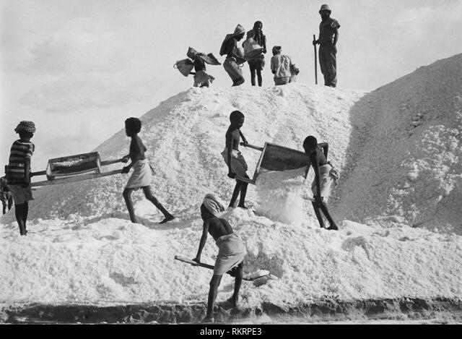
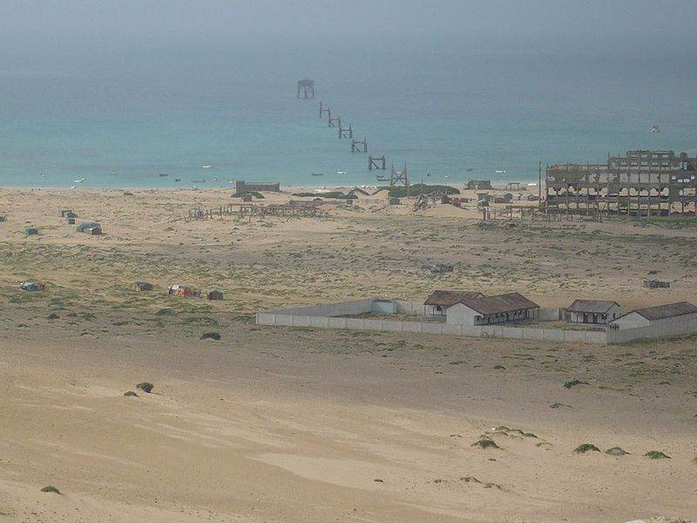 Photo 9: Hafun Salt Factory, built in the 1930s

- Telecommunications and ICT sector
In the last 3 decades, Somalia private sector has revolutionized the country’s ICT sector. While access to ICTs is still more prevalent in urban centers than in rural areas, access is among the most affordable on the African continent. The growth of the ICT sector in Puntland state of Somalia is demonstrated by the rising number of fixed and mobile telephone services, increasing use of desktop, laptop, and tablet computers, and the surge in the number, speed, and reach of internet service providers (ISPs).
The pre-war of postal and telecommunication facilities were completely destroyed but local private-sector companies linked with international companies now provide extensive telecommunication and postal service in every spot in Puntland and in the main towns. They provide advanced mobile telephone service, landlines and satellite lines and have branches in many regions.
An international DHL company operates in Puntland and provides rapid postal services throughout the universe within 48hours.
FM radio broadcasting is operated by private entrepreneurs in all towns and provide sustainable information base about the whole world, there also widespread use of Somali speaking Sattelite TV channels by high and middle classes. Due to the Puntland young population which are over 70% in 30 years of age and use frequently internet, there is huge investment opportunity which needs to be exploited such as:
- Investments in Artificial Intelligence
- Broadband and internet services
- Software and hardware development of mobiles industries
- The ability to develop ICT in enterprises and schools for better competitiveness
- E–technology for all government and other public institutions
- Database management centers
- installation of fiber optic etc.
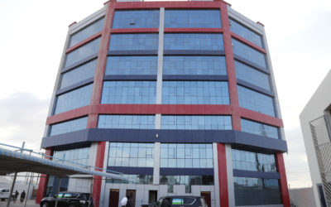
Photo 10: Premises of Golis telecom in Puntland which provides telecommunication and internet broadband
- Health Sector
Investment Opportunities in Health Sector
- Setting up more new hospitals
- Setting up diagnostic centers
- Setting up more casualty center
- Education Sector
Investment Opportunities in Education Sector
- Technical or vocational institutions
- Pre- primary, primary and secondary schools
- Setting up private universities and colleges
- Boarding schools
- Provision of food to schools

END!

